ED 3501 Alberta Program of Studies Overview:
English Language Arts
By: Katherine Abella

Main Ideas/Themes

- The English Language Arts (ELA) Program of Studies recognizes how language is the means of all communication and primary medium of thought

- Thinking, learning and language are interrelated. From Kindergarten to Grade 12, students use language to understand their world and communicate within it

- This is why the aim of English language arts is to enable each student to understand and appreciate language so they can use it skillfully in a variety of situations for communication, personal satisfaction and learning

- The General Outcomes of the ELA Program of Studies relies on the use of six Language Arts that are interconnected:
- Listening
- Viewing
- Representing

- Reading
- Writing
- Speaking

- From Kindergarten to Grade 12, students personally develop and improve these six Language Arts

Major Goals: General Learning Outcomes

- To develop and improve students’ six Language Arts, the ELA Program of Studies has 5 major goals known as General Learning Outcomes that generally remain the same from Kindergarten to Grade 12. They are:
Students will listen, speak, read, write, view and represent to:

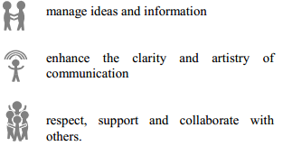
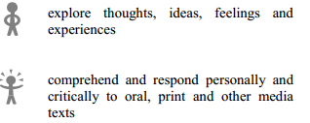

Strands
- The GLOs are divided into more detailed subheadings. For example, General Outcome 1 appears as the following in the K-9 Program of Studies:
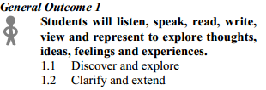
Subheading
Content Scope
- Under each subheading (1.1, etc.), there are side headings that summarize specific outcomes. For example, subheading 2.1 Use Strategies and Cues has the following side headings:
- Use prior knowledge - Use comprehensive knowledge
- Use textual cues - Use phonics and structural analysis
- Use references

- The ELA Specific Learning Outcomes (expected abilities at the end of each grade) are found under these side headings. A Grade 3 SLO appears as such:
General Outcome 2: Students will listen, speak, read, write, view and represent to comprehend and respond personally and critically to oral, print and other media texts

2.1 Use Strategies and Cues
Use Prior Knowledge
- Identify the different ways in which oral, print and other media texts, such as stories, textbooks, letters, pictionaries and junior dictionaries, are organized, and use them to construct and confirm meaning

Content Sequence

- The ELA Program of Studies greatly differs in sequence from other Curriculums such as that of Math and Science because:

- Students rely on using the 6 Language Arts to expand their knowledge and skills from Kindergarten to Grade 12

- In every grade level, the 5 General Outcomes only differ in promoting deeper understanding, effective language strategies, and personal text creation

- K-9 and Grades 10-12 GLO difference: In Grades 10-12, General Outcome #4 is expanded to include the “creation of oral, print, visual and multimedia texts” on top of “enhance the clarity and artistry of communication”. This illustrates the unique ELA sequence of building of knowledge and skill through grade progression

General Features
- In K-9, students use the 6 language arts to engage in specific learning outcomes that develop basic literacy skills and focus on understanding language conventions

- In Grades 10-12, students use the 6 language arts to engage in higher level specific learning outcomes that promote critical thinking, metacognitive skills, and creation of various texts
This is why the ELA Grades 10-12 Program of studies has more content, as seen by specific regulations for studying and producing texts:
1) A minimum of 1/3 of the texts read must be Canadian sources
2) Students must use poetry, prose, script, and multimedia presentations mediums for text creation
Examples
1) Illustrative Example for Grade 3
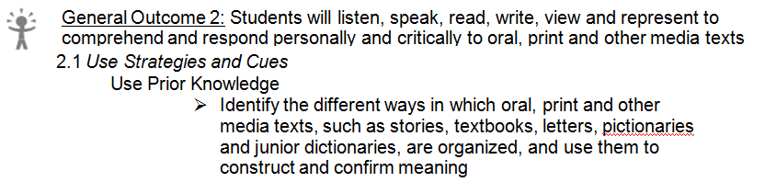
Activity:
1) Share Learning Objective with students: “We are going to compare how different a storybook and a dictionary look inside”
2) Have students in two groups: Give each group the storybook or dictionary and ask them to create a chart that summarizes at least 2 features of their given text
- Give example: “A Textbook has: Table of Contents, Chapters, Summary, etc.”
3) Ask students to share their chart with the class

2) Illustrative Example for Grade 9
General Outcome 3: Students will listen, speak, read, write, view and represent to manage ideas and information
2.1 Share and Review
Review Research Process
- Reflect on the research process, identifying areas of strength and ways to improve further research
Activity:
1) Share Learning Objective with students: “Today we are going to evaluate how we went about doing our research project”
2) Hand out Reflection sheets and let students fill in:
Research Project __________________
I was successful with _________________
I had difficulty with ___________________
Next time, I will ______________________

3) Have students share their reflection

Additional Resources
- K-9 Illustrative Examples: http://education.alberta.ca/teachers/program/english/programs.aspx
- Senior High School English Language Arts Guide to Implementation: http://education.alberta.ca/teachers/program/english/resources/ela-guide.aspx
- Authorized Alberta Resources List, Kindergarten to Grade 9: http://education.alberta.ca/media/645809/elak_9list.pdf
- Alberta Authorized Resources List, Grades 10 to 12: http://education.alberta.ca/media/616845/ela10_12list.pdf
- Read to Live (2006) : http://education.alberta.ca/apps/Readtolive/index.html
– This multimedia resource provides information, strategies and audio/visual clips that encourage teachers and students to think about reading in a new way, focusing on the real-world contexts of home, community and workplace
- Focus on Inquiry (2004): http://education.alberta.ca/media/313361/focusoninquiry.pdf
– Find information and supports for implementing inquiry-based learning activities in the classroom. This guide is designed to assist teachers working on their own or in teams, with or without the support of a teacher-librarian or other library personnel.
- My Child’s Learning: A Parent Resource: http://www.learnalberta.ca/content/mychildslearning/
– Find a summary of what students are expected to learn and be able to do – designed specifically for parents.
- LearnAlberta.ca: http://www.learnalberta.com/ProgramOfStudy.aspx?lang=en&ProgramId=404703# – Link will bring you directly to the English Language Arts Resources. Just choose the grade and Specific Outcome to find resources. Username: lps24 Password: 4095

